System Requirements Statement (SRS) –

FIRST CHOICE-ONLINE SHOPPPING

Doc. Ref. :

Version : 0.4

Status : Drafted

Created by : Kenji Tanaka

Date : 04-Dec-2012

1. Introduction 3

2. Functional Requirements 4

2.1 Customer Module 5

2.2 Vendor Module 11

2.3 Admin Module 17

2.4 Message Acknowledgement Module 21

2.5 Use Case Diagram.............................................................................................................................22

THIS DOCUMENT CONTAINS 23 NUMBERED PAGES

# Introduction

This document explains the system requirements and scope for developing FIRST CHOICE-ONLINE SHOPPPING System.

FIRST CHOICE-ONLINE SHOPPPING System could divide the four main parts, Customer part, Vendor part, Admin part and the acknowledgement part.

This document describes the system requirement of the Account part.

# Functional Requirements

The Account part of FIRST CHOICE-ONLINE SHOPPPING System has three modules which are divided 13 processes described as below.

|  |  |  |
| --- | --- | --- |
| **No** | **BRS requirement ID** | **Description** |
| **2.1** | **Customer Module** | |
| **2.1.1** | **F1** | **Account Creation Process** |
| **2.1.2** | **F2** | **Login Process** |
| **2.1.3** | **F3** | **Search/View Products** |
| **2.1.4** | **F4** | **Add to cart/Removing from cart** |
| **2.1.5** | **F5** | **Viewing the cart** |
| **2.1.6** | **F6** | **View Wallet and Add Money to Wallet** |
| **2.1.7** | **F7** | **Placing the order and making payment** |
| **2.1.8** | **F8** | **Cancelling the order** |
| **2.1.9** | **F9** | **Giving rating to purchased product** |
| **2.1.10** | **F10** | **Logout process** |
| **2.2** | **Vendor Module** | |
| **2.2.1** | **F11** | **Account Creation Process** |
| **2.2.2** | **F12** | **Login Process** |
| **2.2.3** | **F13** | **View Products** |
| **2.2.4** | **F14** | **Add Products** |
| **2.2.5** | **F15** | **Can Give Discount on Products** |
| **2.2.6** | **F16** | **View Out of Stock Products** |
| **2.2.7** | **F17** | **View Wallet** |
| **2.2.8** | **F18** | **Logout** |
| **2.3 Admin Module** | | |
| **2.3.1** | **F21** | **Login Process** |
| **2.3.2** | **F22** | **View Categories** |
| **2.3.3** | **F23** | **Add Category** |
| **2.3.4** | **F24** | **View Product Details** |
| **2.3.5** | **F25** | **View Orders** |
| **2.3.6** | **F26** | **View Vendors** |
| **2.3.7** | **F27** | **View Wallet** |
| **2.3.8** | **F28** | **View Customers** |
| **2.3.9** | **F29** | **Logout** |

## Customer Module

* Customer is the user of system who wants to purchase the product.

* He is also able to view the market prices of products.

### Account Creation Process

* FIRST CHOICE-ONLINE SHOPPPING System compels to create the account before using it. So, FIRST CHOICE-ONLINE SHOPPPING System should provide the function which makes Customer to create new account.
* When Customer creates new account, the function demands two information described as below.

1. Login information

2. Contact Details

* The Login information

The Login information consists of some items described as below.

1. User-ID
2. Password
3. First Name
4. Last Name
5. E-mail address
6. User Type
   * All items are compulsory demanded.
   * User-ID

* The User-ID should be unique. If the User-ID correspond with not case-sensitive to other which is previously registered, the User-ID should not be registered as an account.
  + Password
* The Password has constrains which makes the Password consists of more than or equal 8 and less than or equal 16 characteristics including characters described as below.

1. Numeric figure (at least one)
2. Capital alphabet (A-Z)(at least one)
3. Small alphabet (a-z)(at least one)
4. Special character (#, $, %, &, etc.) (at least one)

* The Password is masked by dummy characters. The re-entering Password is demanded.
* The Password must be encrypted in FIRST CHOICE-ONLINE SHOPPPING System.
  + User Type

The User Type falls into three categories described as below.

1. Customer
2. Vendor
3. Admin

* The User Type defines also three types of users, “Customer user", "Vendor user", and "Admin user”.
* In an Account Creation Process, the user can select Customer.
* No one could select The Admin, because Admin is implemented to FIRST CHOICE-ONLINE SHOPPPING System in advance.
* Contact Details
* The Contact Detail consists of some items described as below.

1. Permanent Address
2. Contact Phone No
   * All items are compulsory demanded.
   * Permanent Address

* Permanent Address should be filled.
* But only the state should be selected from options.
* Login information should be entered on one screen, and then customer information.

### Login Process

* FIRST CHOICE-ONLINE SHOPPPING System always compels user authentication before using itself except when a new account is successfully created.
* The user authentication demands User-ID and Password. The User-ID and the Password should be checked in three ways.
  + First, The User-Id and the Password should be existed and correct.
* If The User-Id and the Password are not equal to what the user has registered, the user authentication cannot be provided.
  + Second, the User Type linked to the User-Id should be "Customer".
* When the User Type is "Customer", then user can be placed on “Customer Home”.
  + Finally, User-Id should be available.
* The Administrator can decide whether the User-Id is available or suspended – Refer to the SRS of the Admin part.
* If customer is rejected, user authentication is not provided for system user.
* The customer account should alive for so long as the duration decided by Admin.
* Only when the three checks are successfully completed, customer can be placed on respected page.
* The “Customer Home” provides some items described as below.

1. A trigger to Registration/Login.
2. A trigger to Search/View Products
3. A trigger to Select Products
4. A trigger to add products to cart
5. A trigger to remove the product from cart.
6. A trigger to view the cart.
7. A trigger to place the order.
8. A trigger to make payment (Wallet update).
9. A trigger to Logout.

### Search/View Products

* Search conditions are described as below.

1. Product Category
2. Price range

* View conditions are described as below.

1. Name of Product
2. Style
3. Size
4. Brand-name

### Add to Cart/Removing from Cart

* FIRST CHOICE-ONLINE SHOPPPING System should provide the function to Customers, that he can able to add products to shopping cart with a single click or tap, so that he can easily collect and organize items he wants to purchase.
* Also, he can able to remove items from shopping cart, either individually or in bulk, so that he can manage and refine his selection before proceeding to checkout.

### Viewing the Cart

* FIRST CHOICE-ONLINE SHOPPPING System should provide the function to Customers, that he can able to view his shopping cart with all the items he has added, including product details, quantities, prices, and any applicable discounts or promotions, so that he can review his selections before proceeding to place the order and making payment.

### View Wallet And Add money to Wallet

* FIRST CHOICE-ONLINE SHOPPPING System should provide the function to Customers that he can able to be able to view his wallet balance and transaction history, so that he can track his available funds and monitor his wallet activity within the e-commerce application.
* Also, the option to add money to his wallet directly within the e-commerce application, so that he can conveniently top up his funds for future purchases.

### Placing the Order and making the Payment(Wallet Update)

* FIRST CHOICE-ONLINE SHOPPPING System should provide the function to Customers to review the details of his order, including the selected products, quantities, and shipping address, before confirming the purchase, so that he can ensure accuracy and make any necessary adjustments.
* customer, will receive a clear summary of his order, including the total cost, applicable taxes, and any discounts or promotions applied, before finalizing the purchase, so that he can have a transparent understanding of the transaction.
* Customer can choose payment method only as Digital Wallet, to complete his purchase, so that he can select the most convenient and trusted option.
* After successful payment, system will send one copy of the bill to the customer’s Email-address and another one for the system data base.

### Cancelling the Order

* FIRST CHOICE-ONLINE SHOPPPING System should provide the function to Customers to cancel their orders within a specified cancellation period
* The cancellation period should be configurable and set by the system admin.
* Once the cancellation deadline passes, users should not be able to cancel the order anymore.
* After successful cancellation of order making the refund to the customer in their Wallet/account.

### Giving ratings to Purchased product

* FIRST CHOICE-ONLINE SHOPPPING System should provide the function to Customers to provide ratings for purchased products using a numerical scale, such as a star rating system.
* The rating scale should be clearly defined, such as 1 to 5 stars, with the option for half-star increments.
* Users should be able to submit their ratings and comments for a product.

### Logout Process

* FIRST CHOICE-ONLINE SHOPPPING System should provide the function to Customers, that he can able to logout on one click or tap.
* After successfully logging out, customers should be presented with a confirmation message indicating their successful logout.
* Users should be redirected to an appropriate page, such as the login page or a homepage, after logging out.

## Vendor Module

### Account Creation Process

* ‘First Choice’ online shopping System compels to create the account before using it. So, ‘First Choice’ should provide the function which makes Vendor creates new account.
* When Vendor creates new account, the function demands information described as below.
  + User Type
  + Login information
  + Contact Details
  + User ID
  + Password
  + First Name
  + Last Name
  + E-mail address
  + All items are compulsory demanded.
  + User-ID
* The User-ID should be unique. If the User-ID corresponds with not case-sensitive to other which is previously registered, the User-ID should not be registered as an account.
  + Password
* The Password has constrained which makes the Password consists of more than or equal 8 and less than or equal 16 characteristics including characters described as below.

1. Numeric figure (at least one)

2. Capital alphabet (A-Z) (at least one)

3. Small alphabet (a-z) (at least one)

4. Special character (#, $, %, &, etc.) (At least one)

* The Password is masked by dummy characters. The re-entering Password is demanded.
* The Password must be encrypted in ‘First Choice’ System.
  + User Type

The User Type falls into three categories described as below.

1. Customer

2. Vendor

3. Administrator

* The User Type defines also three types of users, "Customer user", "Vendor user", and "Administrator user”.
* In an Account Creation Process, the user can select Vendor.
* No one could select The Administrator, because Administrator is implemented to ‘First Choice’ System in advance.
* Contact Details
* The Contact Detail consists of some items described as below.

1. Permanent Address

2. Contact Phone No

* + All items are compulsory demanded.

### Login Process

* ‘First Choice’ System always compels Vendor authentication before using itself except when a new account is successfully created.
* The user authentication demands User ID and Password. The User ID and the Password should be checked in three ways.
  + First, The User ID and the Password should be existed and correct.
* If The User ID and the Password are not equal to what the user has registered, the user authentication cannot be provided.
  + Second, the User Type linked to the User ID should be "user".
* When the User Type is “Vendor”, user can be placed on “Vendor Home”.
  + Finally, User ID should be available.
* The Administrator can decide whether the User ID is available or suspended – Refer to the SRS of the Admin part.
* If user is rejected, user authentication is not provided for Vendor.
* The Vendor account should alive for as long as the duration decided by Admin.
* Only when the three checks are successfully completed, Vendor can be placed on respected page.
* The “Vendor Home” provides some items described as below.

1. A trigger to View Product
2. A trigger to Add Product for sale
3. A trigger to Update Product Information
4. A trigger to Delete Product
5. A trigger to View Wallet
6. A trigger to logout

### View Products

• Vendor could see the list of products which are available for sale.

1. Product name

2. Price

3. Quantity

4. Photos

5. Ratings

### Add Products

* Vendors should be able to add, edit, and delete their products.

1. Select Category Name

2. Product Name

3. Product Description

4. Product Brand

5. Quantity

6. Price

7. Add Product Image

### Can Give Discount on Products

* As Vendor, he can able to offer discounts on specific products or product categories, so that he can attract customers, promote sales, and incentivize purchases.

### View Out of Stock Products

* Vendor should be able to see and add out of stock product and inventory management should be available to Vendors.

### View Wallet

* Each Vendor should have a wallet balance associated with their account.
* The balance should reflect the funds available to the Vendor for withdrawal or use within the platform.
* **Payment Processing**
* When a user purchases a product from a Vendor, the payment should be processed and credited to the Vendor's wallet.
* Integration with a secure payment gateway should facilitate the seamless transfer of funds from the buyer to the Vendor's wallet.

### Logout

* Vendors should have the ability to log out of their accounts by clicking on a "Logout" button or link.
* Upon logout, the Vendor should be redirected to the login page or a designated landing page.
* When a Vendor logs out, their session data should be cleared to remove any stored information related to their account.

## Admin Module

**•** Adminshould be responsible for following activities**,**

### Login Process

* ‘First Choice’ online shopping System always compels user authentication before using itself except when a new account is successfully created.
* The user authentication demands User-ID and Password. The User-ID and the Password should be checked in two ways.
  + First, The User-ID and the Password should be existed and correct.
* If The User-ID and the Password are not equal to what the admin has registered, the admin authentication cannot be provided.
  + Second, the User Type linked to the User-ID should be "Admin".
* When the User Type is "Admin", user can be placed on “Admin Home”.
* The admin account should alive for so long as the duration decided by Admin.
* Only when the two checks are successfully completed, Admin can be placed on respected page.
* The “Admin Home” provides some items described as below.

1. A trigger to logout
2. A trigger to Add Product Category
3. A trigger to View current Categories
4. A trigger to View Product Details
5. A trigger to View Customers
6. A trigger to View Vendors
7. A trigger to View all Order details

### View Categories

* Admin could see the list of Categories which are available.

1. Category ID
2. Category Name
3. Category Type

### Add Category

* Admin should be able to add, edit, and delete product categories.

1. Category Name
2. Category Type

### View Product Details

* Admin should be able to view new products added into the existing system with all its details about the product

1. Product ID
2. Vendor Name
3. Product Name
4. Category Type

### View Orders

* Administrator should be able to view the Orders which are generated by the users. He can verify the details of the purchase.

1. Order ID
2. User Name
3. User Contact No
4. Order Status
5. Order Price
6. Order Quantity

### View Vendors

* Admin should able to manage all the Vendors with following activities,

1. Enable accounts
2. Disable accounts

### View Wallet

* Admin can able to view his wallet where he receives payments after each order.
* FIRST CHOICE-ONLINE SHOPPPING System should have a mechanism to calculate the profit generated from each order.

### View Customers

* Admin should be able to view the details of customers visiting the system.

### Logout

* Admin should have the ability to log out of their accounts by clicking on a "Logout" button or link.
* Upon logout, the admin should be redirected to the login page or a designated landing page.
* When Admin logs out, their session data should be cleared to remove any stored information related to their account.

#### 2.5 Use Case Diagrams

**Customer:**

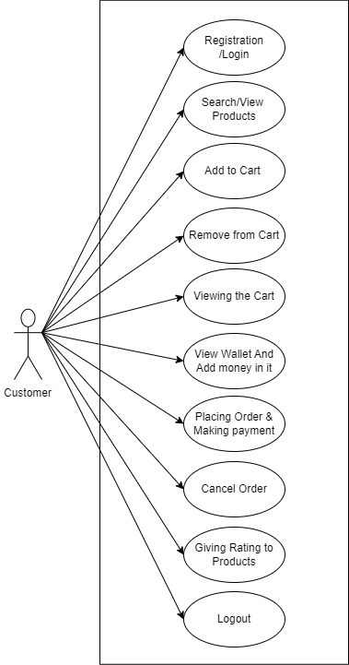

*Fig. Use case diagram for Customer*

1. In Customer use case diagram Customer is the Actor.
2. Customer can handle following use cases:
3. Registration/Login
4. Search/View Product
5. Add to cart
6. Remove from cart
7. View Cart
8. View wallet & add money
9. Place order
10. Cancel order
11. Giving rating for purchased product
12. Logout

**Vendor:**

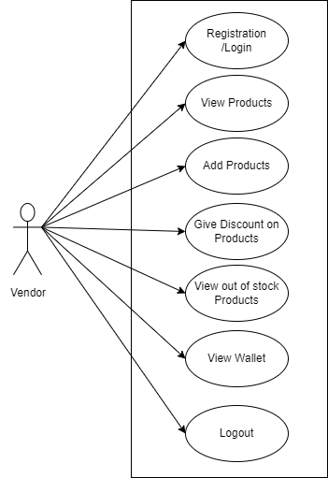

*Fig. Use case diagram for Vendor*

1. In Wholesaler use case diagram Vendor is the Actor**.**
2. Vendor can handle following use cases:
3. Register/Login
4. Add Sub-Categories
5. View Added Products
6. Out of Stock
7. Wallet
8. Logout

**Admin:**

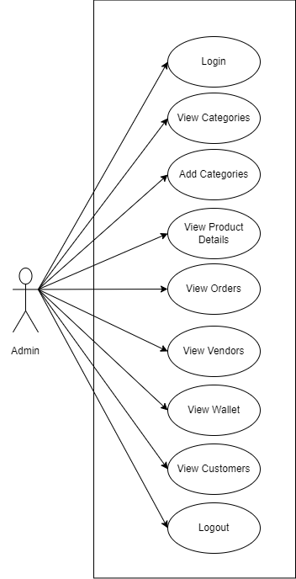

*Fig. Use case diagram for admin*

1. In Admin use case diagram Admin is the Actor.
2. Admin can handle following use cases:
3. Login
4. Authenticate Vendor
5. Add Category
6. Order Details
7. Product Details
8. Vendor Details
9. Logout